**C211 Study Guide Questions**

The following questions are developed as a study aid for the C211 COS. They cover important concepts in each competency. The questions are designed to serve as an indicator of your preparedness to take the C211 assessment. You can use these to help you take notes as you go through the chapters. You may also use them to reinforce your understanding after covering the material.

# Competency 1: Business Decision Making in the Global Environment

**Globalization (Peng Chapters 1, 5, 6, 11)**

1. What determines the success and failure of firms around the globe?
2. List and briefly explain the two views (core perspectives) for global business.
3. What is globalization? Explain the three views on globalization.
4. What is a trade deficit, trade surplus, and balance of trade?
5. What are the theories of international trade?
6. What is FDI? Identify and define the key terms associated with FDI.
7. What is the OLI advantage? (Explain)
8. What are the political views on FDI? (Explain)
9. What are the costs and benefits of FDI to the host country? (Explain)
10. What are the costs and benefits of FDI to the home country? (Explain)
11. How do resources and capabilities influence the competitive dynamics of a business? (Give an example)
12. What is resource similarity and how does this impact competitive dynamics? (Give an example)

**International Trade and Foreign Exchange Market (Peng Chapters 5, 7, 10)**

1. What is a trade deficit, trade surplus, and balance of trade?
2. Why do nations trade?
3. Describe classical and modern international trade theories (what differences exist?)
4. Explain the three types of classical international trade theories.
5. Who came up with the invisible hand and absolute advantage theories?
6. What is the relationship between mercantilism and protectionism?
7. What are the three stages of the product life cycle? Describe each stage with respect to output.
8. How would you describe strategic trade? Give an example.
9. What is an exchange rate? How do supply and demand determine the exchange rate of a country?
10. What are fixed, pegged, floating, managed float exchange rates?
11. Explain the concept of “hedging” as it relates to reducing various types of risk.
12. What is the difference between currency hedging and strategic hedging?
13. If a company seeks to limit foreign exchange rate exposure in the forward direction, what is the most effective way to do this?
14. Give an example of first and late movers and list each mover’s advantages.
15. What are the two models of foreign market entries? Describe each scale of entry with examples.

# Competency 2: Political and Economic Forces

# **Political and Economic Forces (Peng Chapter 2)**

1. How do institutions reduce uncertainty?
2. Discuss and compare the three pillars (regulatory, normative, and cognitive)
3. Compare formal and informal institutions.
4. On what is the institution-based view of global business grounded? What core propositions lie at the root of this view?
5. Describe the political system of Totalitarianism, including the distinct types of totalitarian regimes.
6. Describe the political system of Democracy.
7. Compare and contrast the different legal systems.
8. Civil Law
9. Common Law
10. Theocratic Law
11. Compare and contrast Market Economy, Command Economy, and Mixed Economy.
12. What are the business implications for conducting international business in countries with different political and economics systems?
13. What is Political Risk? Describe and provide examples.
14. What are property rights and how are they protected?
15. How is intellectual Property protected?
16. What are the reasons why intellectual property protections are critical in today’s global business environment?

# Competency 3: Economic Decision Making by Firms and Consumers

# **Consumer Behavior (Mankiw Chapter 21)**

1. What does an Indifference Curve show/represent?
2. Given the picture below, answer the following questions:
   1. What is the point most preferred. Explain why.
   2. Explain why this person would be equally happy at points B and D.
   3. What would be the optimal consumption point. Explain why.   
      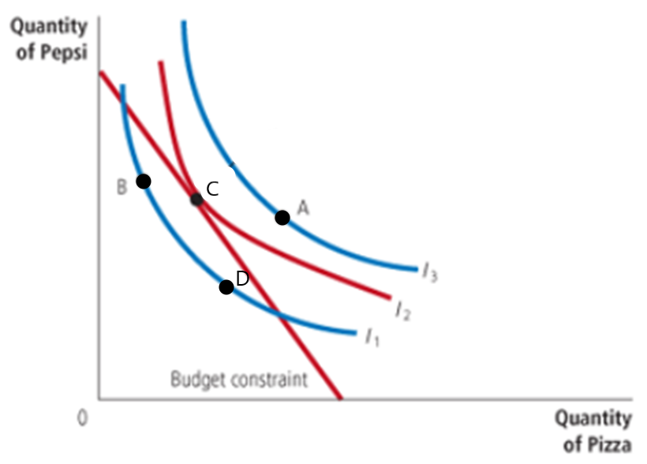
3. What is a budget constraint? What information is being represented by the constraint?
4. How would a budget constraint be impacted by the following:
   1. an increase in income
   2. if the price of one of the goods increased
   3. if the prices of both goods decreased by 10%.

**Firm Behavior Under Different Market Structures (Mankiw Chapters 13-17)**

1. Describe Marginal Cost in your own words.
2. Explain why Marginal Cost must be rising if Marginal Product is falling.
3. Using the image below, explain why average total cost must be rising if marginal cost is above average total cost.

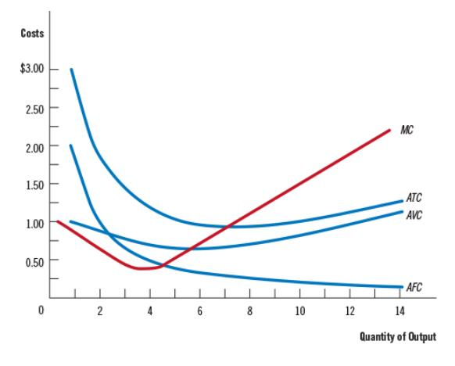

1. If Dave’s company has a total cost of $100 when quantity output is 5, and a total cost of $115 when quantity output is 6,
2. What is the marginal cost of producing the 6th unit?
3. Explain why Dave’s company would not want to accept a price below the Marginal Cost?
4. Total cost is made of two types of costs; what are they? Give an example of both types of costs.
5. Explain why the supply curve for a perfectly competitive firm is the marginal cost curve above average variable cost?
6. How does a firm determine whether to shut down in the short run?
7. Give an example of a firm shutting down in the short run from the real world. The example can be hypothetical.
8. What is the Nash Equilibrium of the prisoner’s dilemma below? **Explain** in your own words why this is the Nash Equilibrium: 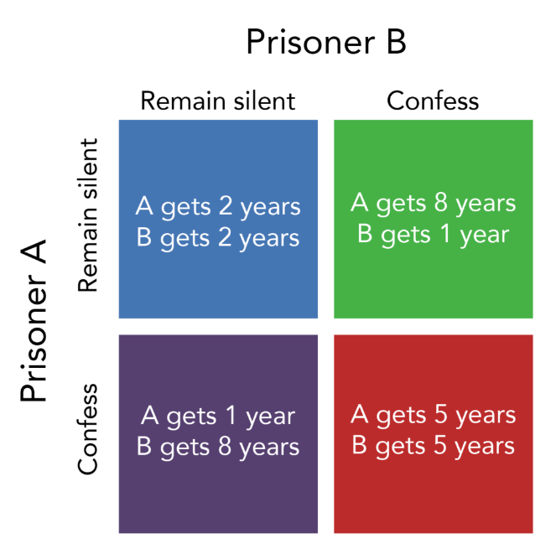

1. In the scenario below, two water companies are deciding whether to set their prices High or Low. The numbers in the box are the profit outcomes from each decision. Assuming the firms cannot collude or form a cartel, what would be the Nash Equilibrium of this game? **Explain** in your own words why this is a Nash Equilibrium?

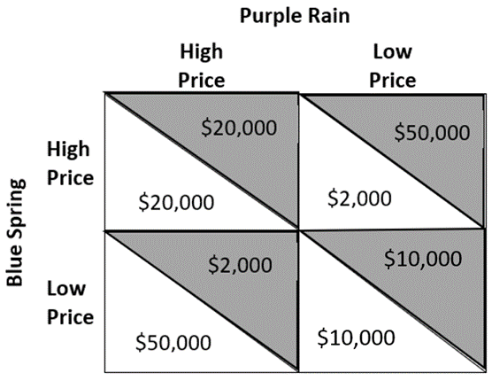

1. What does the Prisoner’s Dilemma tell us about behavior of a duopoly and the formation of a cartel?
2. What may prevent an oligopolistic firm from forming a cartel?
3. Complete the following table of market structure characteristics as you go through each chapter.

|  |  |  |  |  |
| --- | --- | --- | --- | --- |
|  | **Perfect Competition** | **Monopolistic Competition** | **Oligopoly** | **Monopoly (Monopolist)** |
| **Example of Firms in this market** |  |  |  |  |
| **Number of Firms** |  |  |  |  |
| **What is the shape of a firm’s demand curve?** |  |  |  |  |
| **Products are Differentiated, Identical, Both, or Unique** |  |  |  |  |
| **What is the firm’s rule for Profit Maximization?** |  |  |  |  |
| **Are firms price-takers or price-makers?** |  |  |  |  |
| **Are there any barriers to Entry?** |  |  |  |  |
| **Can firms make Long-run economic profits?** |  |  |  |  |
| **Are firms likely to advertise?** |  |  |  |  |
| **Do firms produce the Efficient level of Output?** |  |  |  |  |
| **Are firms likely to collude?** |  |  |  |  |

# Competency 4: Microeconomics and Macroeconomic Principles

**Macroeconomic Principles (Mankiw Chapters 29 & 34)**

1. What is the discount rate?
2. What is the Federal Funds rate?
3. What is the required reserve ratio?
4. What tools does the Federal Reserve have to change the money supply?
5. What three actions could the Federal Reserve take to DECREASE the money supply?
   1. What impact will the decrease in the money supply have on the interest rate?
   2. What impact with the change in interest rate have on aggregate demand?
6. How can the Federal Reserve DECREASE the interest rate? What impact will that have on the aggregate demand? Explain briefly.
7. What is the crowding out effect and how might it affect interest rates?
8. What is the expenditure multiplier effect?
9. If government spending increases, using the multiplier effect, is the effect on aggregate demand (AD) larger or smaller than the increase in government spending?
10. If the government uses fiscal policy to increase government spending, what impact will this have on aggregate demand?
11. If the government uses fiscal policy and increases taxes, what effect will this have on aggregate demand?
12. What are automatic stabilizers? Give two examples.

**Microeconomic Principles (Mankiw Chapters 4 & 5)**

1. What is the difference between Microeconomics and Macroeconomics?
2. What is the law of demand? How does this relate to the shape of the market demand curve?
3. What is the difference between a change in demand and a change in quantity demanded?
4. What are the factors that shift the demand curve?
5. If a person’s income increases, what happens to the person’s demand? 5. What is supply. What are the factors that shift the supply curve?
6. What is price elasticity of demand? Explain the differences, including the values, between elastic, inelastic, and unit-elastic.
7. What is income elasticity and how is it measured?
8. What is the difference between a normal good and an inferior good? What does income elasticity tell us about the differences?
9. What is cross-price elasticity? What do the values of cross-price elasticity tell us about substitutes and complements?
10. If demand and supply both increase, how does equilibrium price (P) and quantity (Q) change?

# Competency 5: Assessing Global Economic Performance and International Trade

**Measuring Economic Performance (Mankiw Chapters 7 & 23)**

1. Explain why national income must be equal to national expenditure in the economy as a whole?
   1. Why are transfer payments such as social security not counted in government expenditures?
2. Describe consumer surplus in relation to the price and willingness to pay.
   1. Which area(s) represent consumer surplus on the following graph.

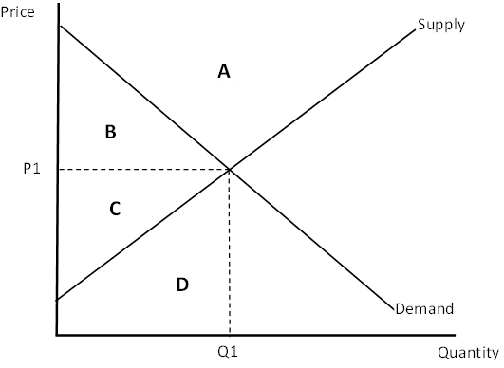

1. Describe producer surplus in relation to the price and producer costs
   1. Which area(s) represent producer surplus on the following graph.



1. What is total surplus?
   1. What can it tell us about market efficiency?
   2. In what ways might surplus measures be used in developing government policy?
2. Define gross domestic product (GDP).
3. Given the following items, state whether or not they would be included in calculating GDP for a country for 2021.
   1. A car produced in March 2021.
   2. Flour produced that is used by a bakery to make bread.
   3. A parent staying home to take care of their children.
   4. Vegetables sold by a grocery store to a customer.
   5. A house built in 2004 and sold in August 2021.
4. Describe the four components of GDP and explain how they affect aggregate demand.
5. What is the difference between real and nominal GDP?
   1. What is the value of measuring GDP in real terms?
   2. What does the GDP deflator measure?
6. In what ways might GDP not be a good measure of well-being?

**International Trade (Mankiw Chapter 9)**

1. Why do countries choose to trade?
2. When a country opens up to free trade of a good, a country will be an exporter or an importer of that good.
   1. If the country chooses to export the good, who are the winners and losers?
   2. If the country chooses to import the good, who are the winners and losers?
3. Explain the difference between tariff and nontariff trade barriers.
   1. Discuss an example of a nontariff trade barrier which has been imposed by the United States on another country.
   2. What was the intended purpose of that trade barrier?
   3. How would you determine if it was effective?
4. When an import tariff is imposed, explain how each of the following are impacted
   1. Domestic price
   2. World price
   3. Domestic sellers
   4. Domestic buyers
   5. Domestic government
   6. Foreign sellers
5. Using the answer to #4, discuss the concept of deadweight loss relating to concepts of consumer and producer surplus when a tariff is imposed.
6. Explain the five reasons a country might restrict trade.
7. Consider the example of a tariff placed on the import of Chinese manufactured steel into the United States.
   1. Discuss how the actual price of steel purchased by a car manufacturer in Detroit Michigan will be affected after the tariff is imposed.
   2. Where does the tariff tax collected end up?
   3. What would likely happen to the domestic production of steel after the tariff is imposed?
   4. What would likely happen to the quantity demanded for steel in the United States?